CERTIFIED PRODUCTIVITY SPECIALISTS COURSE
APPLICATION FORM
Full Name (As per NRIC) | Nationality
- Singapore Citizen
- PR
- Other: ____________________________
Gender | NRIC No. (collecting on behalf of SSG)
- Male
- Female
Contact Number | Billing Address
Email | Enrolment
- Individual
- Organisation
Name of Organisation | Organisation Address
Designation | Organisation UEN Number
Highest Education Level Attained | Professional Qualification
Funding Options
- SkillsFuture Credit (SkillsFuture Singapore)
*Require to provide a screenshot of your remaining credits to SGPC upon submission of this application form.
- SkillsFuture Study Award (Enterprise Singapore)
Selection of course
* Please note that there will be no refund or cancellation. Prices are subjected to prevailing GST.
- Core Segment + Specialisation Food Segment: S$498 + S$4,998 = S$5,496
- Core Segment + Specialisation Retail Segment: S$498 + S$4,998 = S$5,496
- Core Segment + Specialisation Food Segment: S$1,998 + 3.5 - man days consultancy
- Core Segment + Specialisation Retail Segment: S$1,998 + 3.5 - man days consultancy

Terms and Conditions
- Participant Fees
All participants must pay the applicable fees before start of the programme. The payment can be made in cash, cheque or bank transfer.
If you are making the payment by cheque, please issue the cheque to Singapore Productivity Centre (indicate participant’s name and workshop title on the reverse of your cheque). Mail the cheque to: Singapore Productivity Centre, 11 Eunos Road 8, #08-01 Lifelong Learning Institute Singapore 408601.
- Cancellation Policy

There will be no refund or cancellation (inclusive of no-show).

- Liability

SGPC reserves the right to amend any part of the programme if necessary at any time. Kindly note that seats are limited and reservations are subjected to final confirmation.

- PDPA Agreement
I agree that Singapore Productivity Centre (SGPC) may collect, use and disclose your personal data, which you have provided in this form, for providing marketing material that you have agreed to receive, in accordance with the Personal Data Protection Act 2012. Information sent by our organisation about our organisation’s products and services, including updates on our latest promotions and new products and services will be disseminated via email.

Do you agree to the Terms and Conditions above:
- Yes, I do

Programme Secretariat, please contact:
Mr Thomas Chia
Tel: 6745 5833 / 9644 5550
Email: thomas_chia@spa.org.sg

Ms Stephanie Goh
Tel: 6745 5833 / 9654 8013
Email: stephanie_goh@sgpc.sg

Ms Cheryl Chan
Tel: 6745 5833

Email: cheryl_chan@sgpc.sg

SkillsFuture Study Award for Food Services and Retail
Enterprise Singapore (ESG)

Eligibility Criteria for Food Services

- Singaporeans with minimum 3 years of work experience in the Food Services industry
- Seeking to upgrade skills in the Front-of-House and Back-of-House functions in the industry
- Has strong career aspirations, able to see himself/herself contributing in the sector 3–5 years down the road
- Meets entry requirements for selected course of study
- Not a previous recipient of any SkillsFuture Study Award
- Applicants are encouraged to submit their application before course commencement. Applications submitted after course commencement will be considered on a case by case basis. Successful applicants are to commence their approved course within one year from the date of application.

Eligibility Criteria for Retail

- Singaporeans with minimum 2 years of work experience in the Retail industry
- Able to apply skills acquired at work and overcome challenges
- Committed to deepening skills in the industry; seeking to develop retail management and emerging skills sets
- Has track record of contributing to the learning or training of self and/or others
- Has strong career aspirations; able to see himself/herself contributing in the sector 3–5 years down the road
- Meets entry requirements for selected course of study
- Not a previous recipient of any SkillsFuture Study Award
- Shareholders of a retail company will be considered on a case-by-case basis, after assessment of involvement level in company operations
- Applicants are encouraged to submit their application before course commencement. Applications submitted after course commencement will be considered on a case by case basis. Successful applicants are to commence their approved course within one year from the date of application.

Evaluation Process
Evaluation:
- Fulfilment of basic eligibility criteria does not guarantee a successful award as evaluations will be based on the merits of each application.
- Applications with incomplete or inaccurate documentation will be rejected. ESG may contact the applicant and/or referees for further clarification.
- Evaluations will take approximately 6 to 8 weeks after the respective application closing dates (Please refer to the Application Period table below). Successful applicants will receive a Letter of Undertaking via post while unsuccessful applicants will be notified via email. Successful applicants are to reply with acceptance within 1 week from date of e-offer, otherwise offer will be considered as lapse.
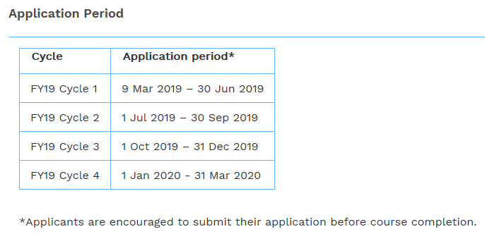
Application Process
Click on "Apply Now" to submit an application via the online portal. Please upload the following documents in the online portal:
- Copy of your coloured NRIC (both sides)
- Course acceptance letter (if any)
- Letter of recommendation/testimonial from your current or previous employer OR Contact details of 2 referees with prior or existing working relationships with you (if any)
- How did you find out about the SkillsFuture Study Award?
  - Internet searches (e.g. Google)
  - Facebook
  - LinkedIn
  - Recommendation from my organisation / HR
  - Training provider
  - SkillsFuture website
  - Others: __________
Claim Process
Successful applicants will receive an e-LOF which they are to reply with their acceptance within 1 week from the date of e-offer, otherwise their offer will be considered as lapsed.

All awardees are encouraged to submit the following documents within 1 month from the date of offer acceptance to receive a once-off disbursement of $5,000:
- Original signed Claim Form
- Completed GIRO Form
- Proof of acceptance into the course indicating the full course period (i.e. start date and end date of the course)
- Course attendance OR Certificate of completion (if applicable)

The award is valid for one calendar year. If the required documents are not received within 12 months from the date of offer acceptance, the award will be considered as lapsed.
Disbursements will take approximately 8 to 12 weeks after the receipt of complete documents. All applicants will be notified on their disbursements via email.
Enquiries
Please refer to the Frequently Asked Questions or email:
Food Services: SFStudyAwards_Food@enterprisesg.gov.sg
Retail: SFStudyAwards_Retail@enterprisesg.gov.sg.

*Please note that Enterprise Singapore do not accept applications via email.
Website: http://www.skillsfuture.sg/studyawards

SkillsFuture Study Award Food Services: click [here] > look for Food Services Category
SkillsFuture Study Award Retail Services: click [here] > look for Retail Category

*For FAQs on the SkillsFuture Study Awards: Please click [here]
Note:
- SGPC will not be held liable for the approval or rejection of the SkillsFuture Study Award application.
- You may use your SkillsFuture Credit concurrently with SkillsFuture Study Award.

SkillsFuture Credit
Login via Singpass to your individual account
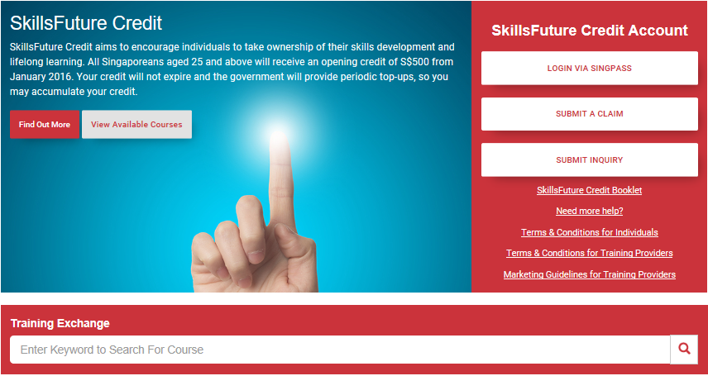
*Screenshot the remaining credits (as shown below) and send this application form along to SGPC.
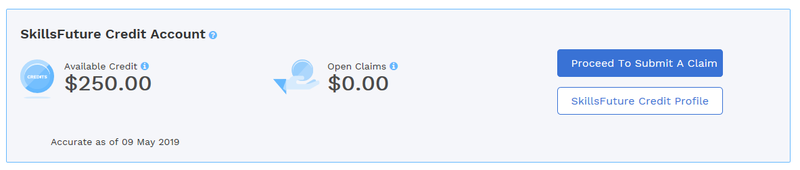
- Click on proceed to submit a claim (Claim can only be submitted within 60 days from the course start date)
- Look for Singapore Productivity Centre (Under Training Providers)
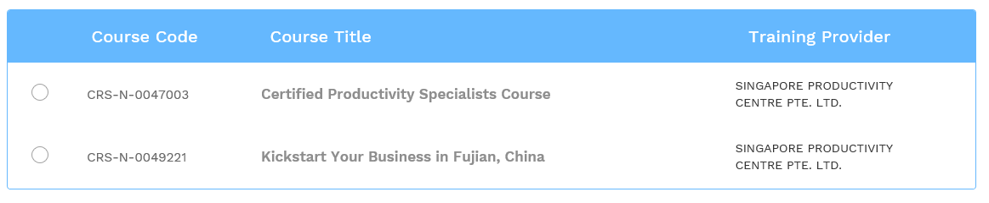
- Look for Course title: Certified Productivity Specialists Course / Course Code: CRS-N-0047003

For FAQs on the SkillsFuture Credit: Please click [here]

