CERTIFIED PRODUCTIVITY SPECIALIST (CPS)
COURSE APPLICATION FORM

Full Name (as per NRIC) | NRIC No. (collecting on behalf of SSG)
Gender | Nationality
- Male  - Female | - Singapore Citizen  - PR  - Others: ____________________________
Contact Number | Email Address
Billing Address | Enrolment
- Individual
- Organisation
Name of Organisation | Organisation UEN Number
Designation | Organisation Address
Highest Education Level Attained | Professional Qualification
Funding Options
- SkillsFuture Credit* (by SkillsFuture Singapore)
- SkillsFuture Study Awards (by Enterprise Singapore)

*Required to provide a screenshot of applicant’s remaining SkillsFuture Credit to SGPC upon submission of this application form.
Course Selection
- Core + Food Services Specialisation: S$498 + S$4,998 = S$5,496
- Core + Retail Specialisation: S$498 + S$4,998 = S$5,496

*Prices are subjected to prevailing GST. Please refer to Terms & Conditions below.

Terms and Conditions

- Payment
Applications will only be confirmed upon receipt of full payment of the course fees, prior to course commencement. Payment can be made via Cash, Bank Transfer or Cheque.
Cheque payment must be made payable to “Singapore Productivity Centre”. Please indicate the participant’s name and workshop title on the reverse of the cheque clearly and mail the cheque to:
Singapore Productivity Centre
11 Eunos Road 8, #08-01
Lifelong Learning Institute
Singapore 408601

- Transfers & Cancellation Policy

The course fee is strictly non-refundable and non-transferable. Cancellation and withdrawal, under any circumstances, inclusive of absenteeism will not be accepted.

- Liability

Singapore Productivity Centre (SGPC) reserves the right to revise the course venue, trainers, structure and dates should circumstances warrant the need to. SGPC will not

be held liable for the approval or rejection of the SkillsFuture Study Awards funding application.

- Confidentiality & Privacy

By submitting the application form, the applicant shall be deemed to have agreed and consented to the collection, use, disclosure and retain of his/her personal data provided in this form by Singapore Productivity Centre (SGPC) in accordance to the Personal Data Protection Act 2012 (“PDPA”).

Photographs and videos of participants participating in our courses may be taken for our advertising and publicity materials. From time to time, SGPC may contact you via email or telephone for marketing and promotions of our events, workshops and courses, as well as for non-marketing messages such as service-related notices and surveys.

Programme Secretariat, please contact:

Mr Thomas Chia
Contact Number: 6745 5833 / 9644 5550
Email Address: thomas_chia@spa.org.sg

Ms Stephanie Goh
Contact Number: 6745 5833 / 9654 8013
Email Address: stephanie_goh@sgpc.sg

SKILLSFUTURE STUDY AWARDS FOR FOOD SERVICES & RETAIL
BY ENTERPRISE SINGAPORE (ESG)

Eligibility Criteria (Food Services Specialisation)

- Singaporeans with minimum 3 years of work experience in the Food Services industry
- Seeking to upgrade skills in the Front-of-House and Back-of-House functions in the industry
- Has strong career aspirations, able to see himself/herself contributing in the sector in the next 3 – 5 years
- Meets entry requirements for selected course of study
- Not a previous recipient of any SkillsFuture Study Awards
- Applicants are encouraged to submit their application before course commencement. Applications submitted after course commencement will be considered on a case by case basis. Successful applicants are to commence their approved course within one year from the date of application.

Eligibility Criteria (Retail Specialisation)

- Singaporeans with minimum 2 years of work experience in the Retail industry
- Able to apply skills acquired at work and overcome challenges
- Committed to deepening skills in the industry; seeking to develop retail management and emerging skills sets
- Has track record of contributing to the learning or training of self and/or others
- Has strong career aspirations; able to see himself/herself contributing in the sector in the next 3 – 5 years
- Meets entry requirements for selected course of study
- Not a previous recipient of any SkillsFuture Study Awards
- Shareholders of a retail company will be considered on a case-by-case basis, after assessment of involvement level in company operations

- Applicants are encouraged to submit their application before course commencement. Applications submitted after course commencement will be considered on a case by case basis. Successful applicants are to commence their approved course within one year from the date of application.

Evaluation Process
- Fulfilment of basic eligibility criteria does not guarantee a successful award as evaluations will be based on the merits of each application.
- Applications with incomplete or inaccurate documentation will be rejected. ESG may contact the applicant and/or referees for further clarification.
- Evaluations will take approximately 6 to 8 weeks after the respective application closing dates (Please refer to the Application Period table below). Successful applicants will receive a Letter of Undertaking via post while unsuccessful applicants will be notified via email. Successful applicants are to reply with acceptance within 1 week from date of e-offer, otherwise offer will be considered as lapse.
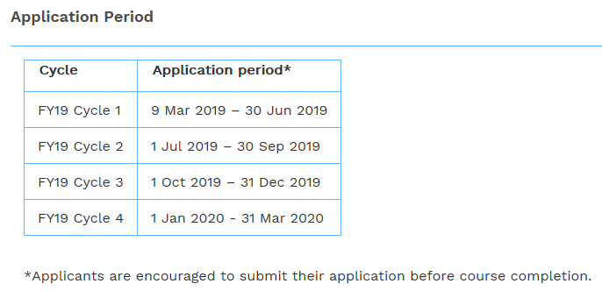
Application Process
Click on "Apply Now" to submit an application via the online portal. Please upload the following documents in the online portal:
- Copy of your coloured NRIC (both sides)
- Course acceptance letter (if any)
- Letter of recommendation/testimonial from your current or previous employer OR Contact details of 2 referees with prior or existing working relationships with you (if any)
- How did you find out about the SkillsFuture Study Awards?
  - Internet searches (e.g. Google)
  - Facebook
  - LinkedIn

  - Recommendation from my organisation / HR
  - Training provider
  - SkillsFuture website
  - Others: __________

Claim Process
Successful applicants will receive an e-LOF which they are to reply with their acceptance within 1 week from the date of e-offer, otherwise their offer will be considered as lapsed.
All awardees are encouraged to submit the following documents within 1 month from the date of offer acceptance to receive a once-off disbursement of $5,000:
- Original signed Claim Form
- Completed GIRO Form
- Proof of acceptance into the course indicating the full course period (i.e. start date and end date of the course)
- Course attendance OR Certificate of completion (if applicable)

The award is valid for one calendar year. If the required documents are not received within 12 months from the date of offer acceptance, the award will be considered as lapsed.
Disbursements will take approximately 8 to 12 weeks after the receipt of complete documents. All applicants will be notified on their disbursements via email.

Enquiries
Please refer to the Frequently Asked Questions or email:
Food Services: SFStudyAwards_Food@enterprisesg.gov.sg
Retail: SFStudyAwards_Retail@enterprisesg.gov.sg.

*Please note that Enterprise Singapore do not accept applications via email.
Website: http://www.skillsfuture.sg/studyawards

SkillsFuture Study Awards (Food Services): click [here] > look for Food Services Category
SkillsFuture Study Awards (Retail): click [here] > look for Retail Category

*For FAQs on the SkillsFuture Study Awards: Please click [here]

Note: Applicants may use their SkillsFuture Credit concurrently with SkillsFuture Study Awards

SKILLSFUTURE CREDIT
BY SKILLSFUTURE SINGAPORE (SSG)

Login via Singpass to your individual account
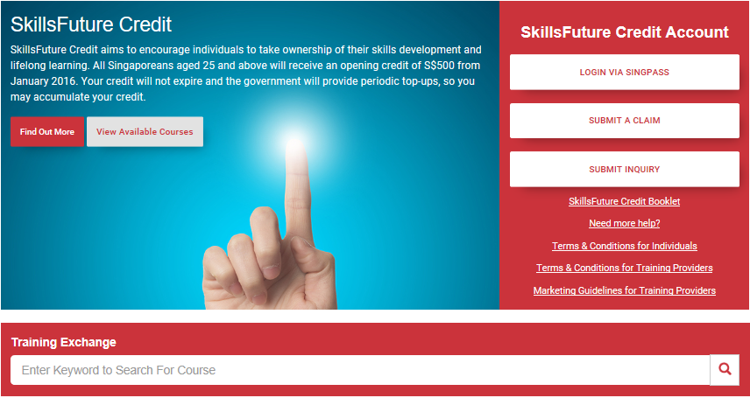
*Screenshot the remaining credits (as shown below) and send this application form along to SGPC.
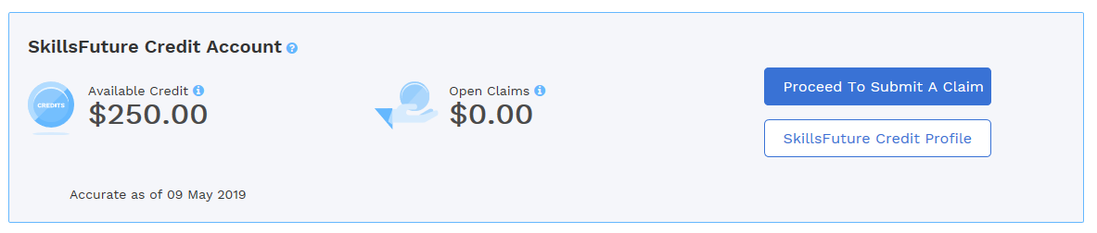
- Click on proceed to submit a claim (Claim can only be submitted within 60 days from the course start date)
- Look for Singapore Productivity Centre (Under Training Providers)
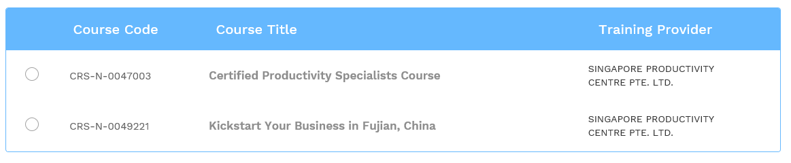
- Look for Course title: Certified Productivity Specialists Course / Course Code: CRS-N-0047003
For FAQs on the SkillsFuture Credit: Please click [here]

